9.43: a) The units of moment of inertia are 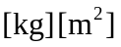 and the units of are equivalent to 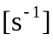 and so the product 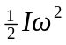 has units equivalent to 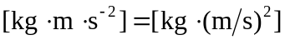, which are the units of Joules. A radian is a ratio of distances and is therefore unitless.
b) 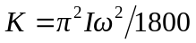, when is in 

